**EXPERIMENT-13**

**Aim:**

To create and configure a Virtual Machine with 1 CPU, 2GB RAM, and 15GB storage disk using Type 2 Virtualization Software (VirtualBox).

**Procedure**

1. Open VirtualBox
   * Launch Oracle VirtualBox from the desktop/start menu.
2. Create a New Virtual Machine
   * Click on "New" in the VirtualBox Manager.
   * Enter the name of the VM (e.g., "My_VM").
   * Select the type and version of the guest operating system (e.g., Linux → Ubuntu 64-bit).
   * Click Next.
3. Allocate Memory (RAM)
   * In the memory size dialog box, allocate 2048 MB (2GB) RAM.
   * Click Next.
4. Create Virtual Hard Disk
   * Select "Create a virtual hard disk now" and click Create.
   * Choose VDI (VirtualBox Disk Image) as disk type.
   * Select Dynamically Allocated storage.
   * Set the disk size to 15GB and click Create.
5. Configure CPU
   * Select the created VM and click Settings → System → Processor.
   * Allocate 1 CPU core.
   * Click OK.
6. Mount Installation ISO
   * In the VM settings, go to Storage.
   * Click on the empty disk icon under Controller: IDE.
   * Choose the downloaded OS ISO file and click OK.
7. Start Virtual Machine
   * Select the VM and click Start.
   * Follow the OS installation steps to complete the setup.

**STEP 1;** Open VirtualBox

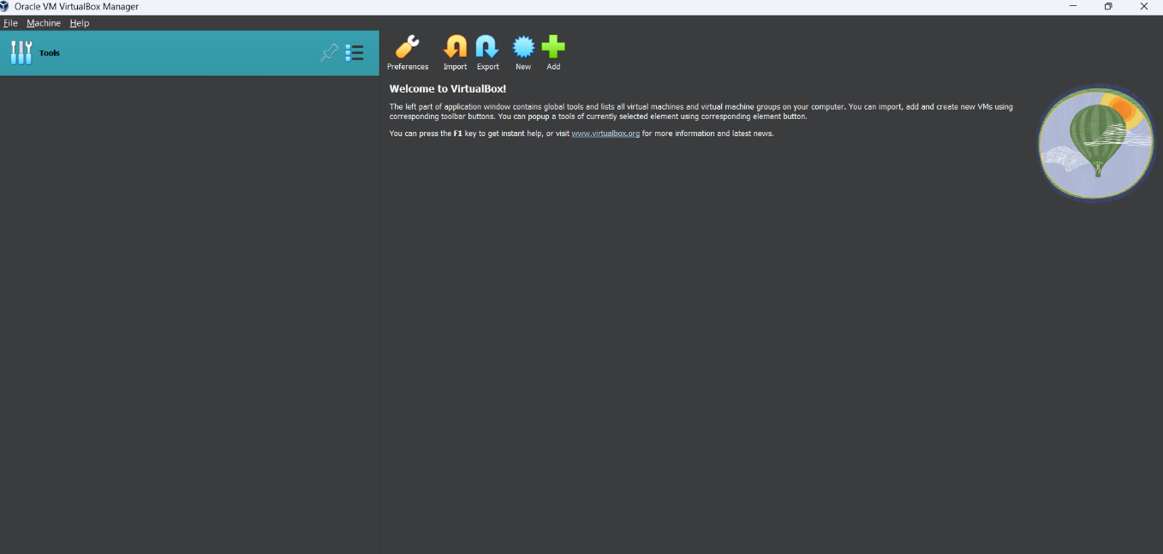

**

**STEP 3:** Allocate Memory (RAM)

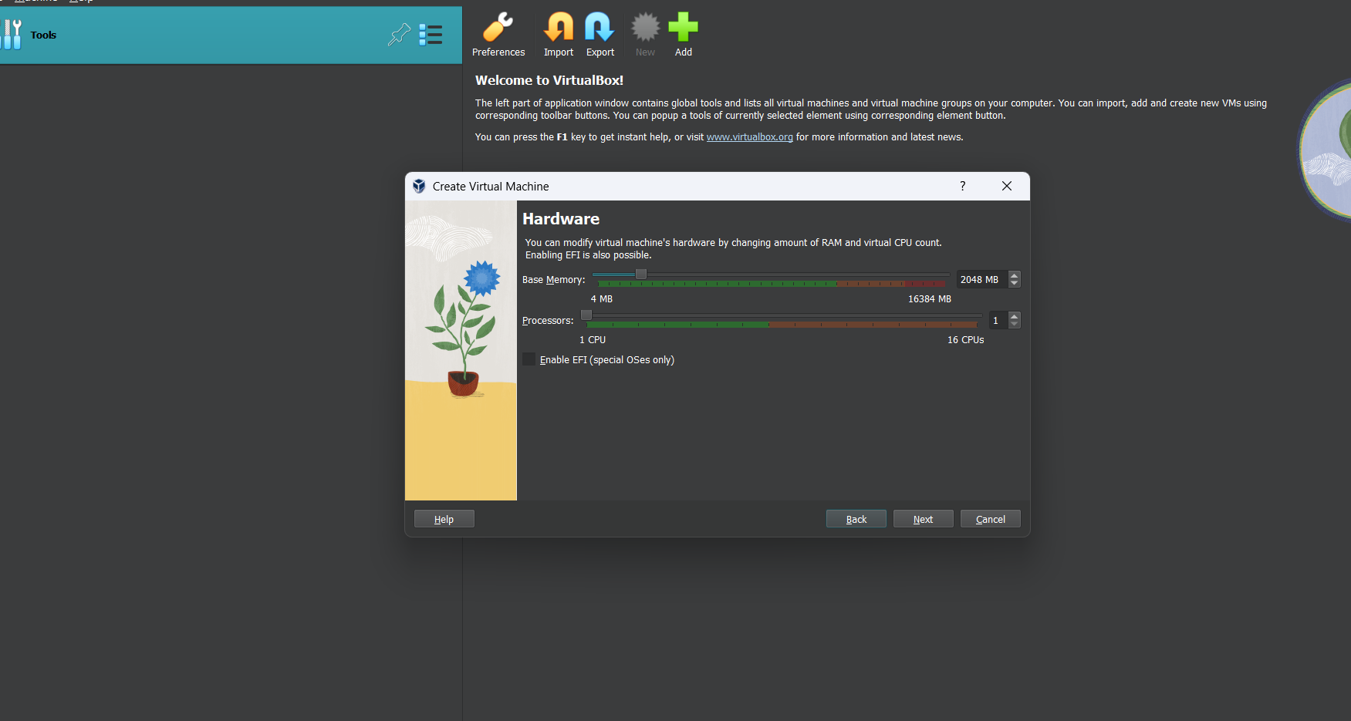

**STEP 4:** Create Virtual Hard Disk

**STEP 5:** Configure CPU

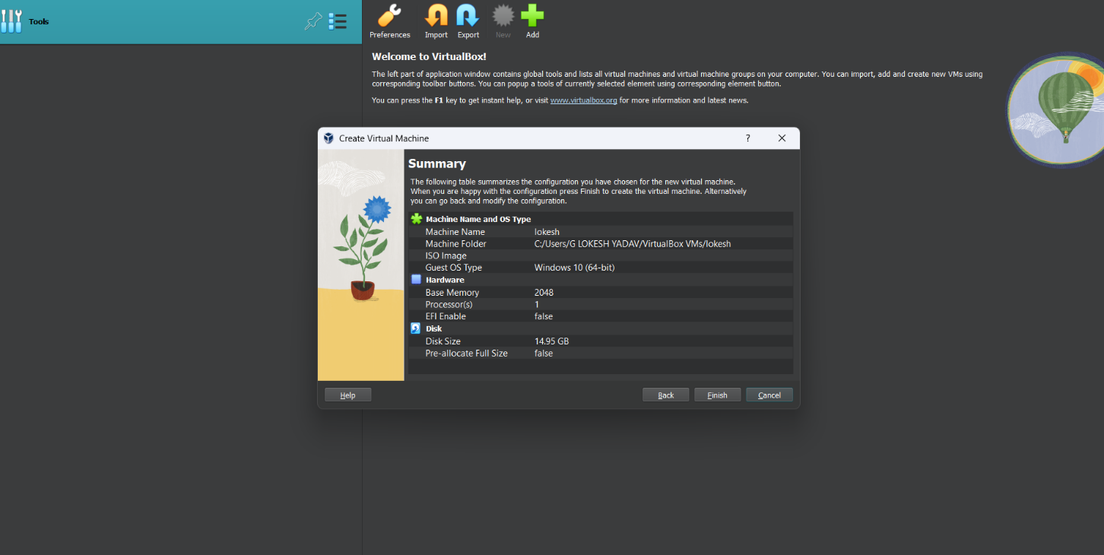

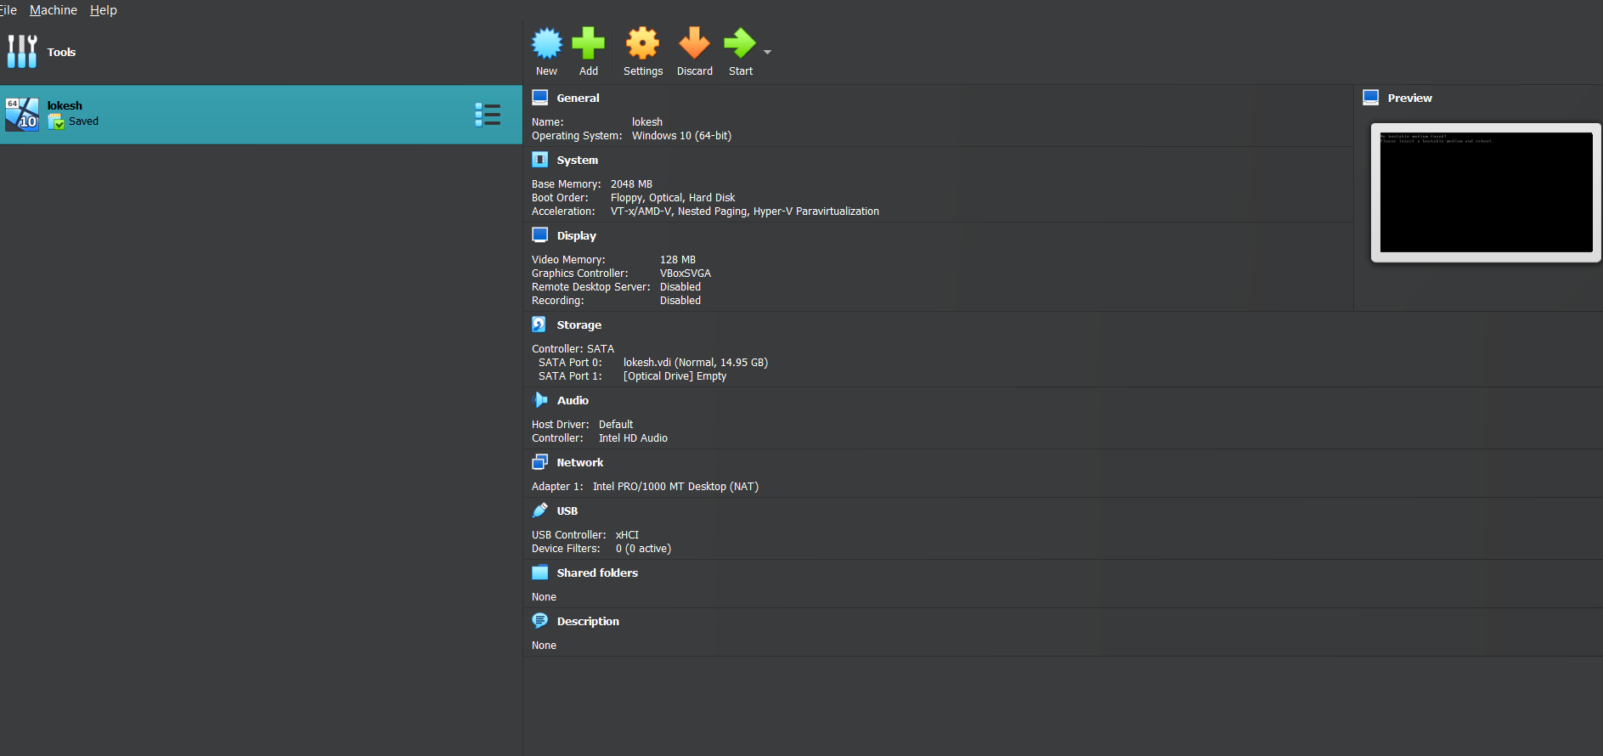

**RESULT:**

A virtual machine with 1 CPU, 2GB RAM, and 15GB storage disk is successfully created and configured using VirtualBox (Type 2 Hypervisor).